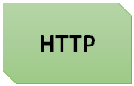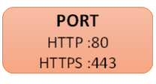

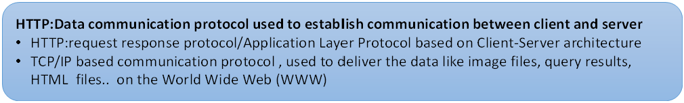

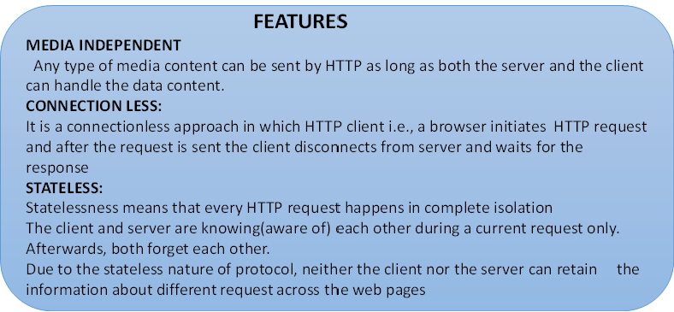

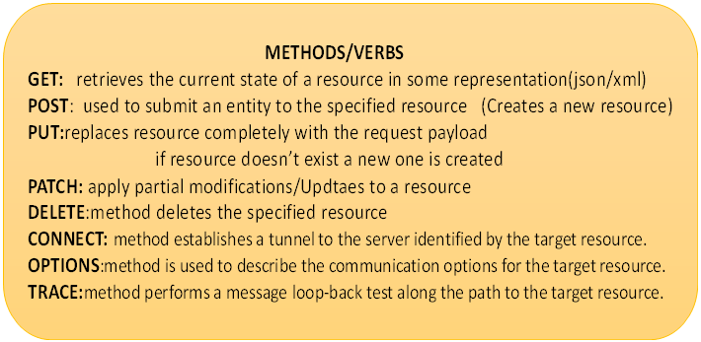

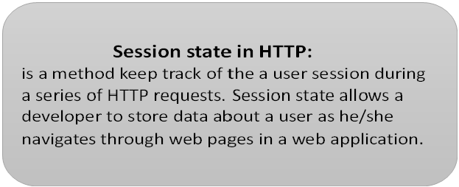

**HTTPS:( Hypertext Transfer Protocol SECURE is an extension of  HTTP)**

* **I**t is used for secure communication over a computer network, and is widely used on the Internet. In HTTPS, **the communication protocol is encrypted using**

**Transport Layer Security (TLS) or**

**Secure Sockets Layer (SSL).**

* The protocol is therefore also referred to as HTTP over TLS, or HTTP over SSL.
* The principal motivations for HTTPS are authentication of the accessed website, and protection of the privacy and integrity of the exchanged data while in transit.
* It protects against man-in-the-middle attacks, and the bidirectional encryption of communications between a client and server protects the communications against eavesdropping and tampering.
* This provides assurance that user is communicating with the website without interference from attackers

**IDEMPOTENCE**:From a RESTful service standpoint, for an operation (or service call) to be idempotent, clients can make that same call repeatedly while producing the same result. In other words, making multiple identical requests has the same effect as making a single request.

Ex**: GET/PUT/Patch/Delete**

**PUT VS POST:**

**->PUT is for creating a new resource(overrides)**

**->PUT/PATCH is for creation or updating the resource**

* The difference between POST and PUT is that PUT requests are idempotent. That is, calling the same PUT request multiple times will always produce the same result. In contrast, calling a POST request repeatedly have side effects of creating the same resource multiple times.-
* Response from PUT is non catchable whereas response from POST is catchable

**Caching**

* is a technique that stores a copy of a given resource and serves it back when requested.
* When a web cache has a requested resource in its store, it intercepts the request and returns its copy instead of re-downloading from the originating server.

This achieves several goals:

* it eases the load of the server ,that doesn’t need to serve all clients itself,
* it improves performance by being closer to the client, i.e., it takes less time to transmit the resource back. For a web site, it is a major component in achieving high performance.
* On the other side, it has to be configured properly as not all resources stay identical forever: it is important to cache a resource only until it changes, not longer.

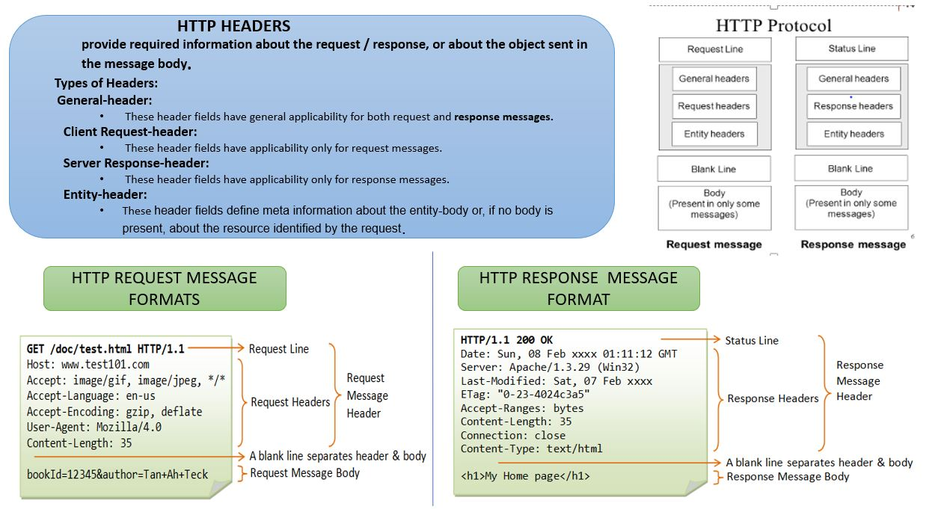

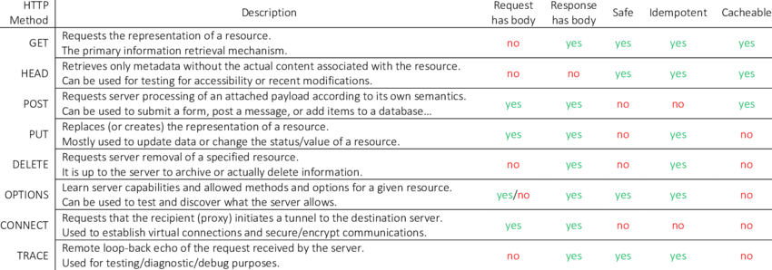

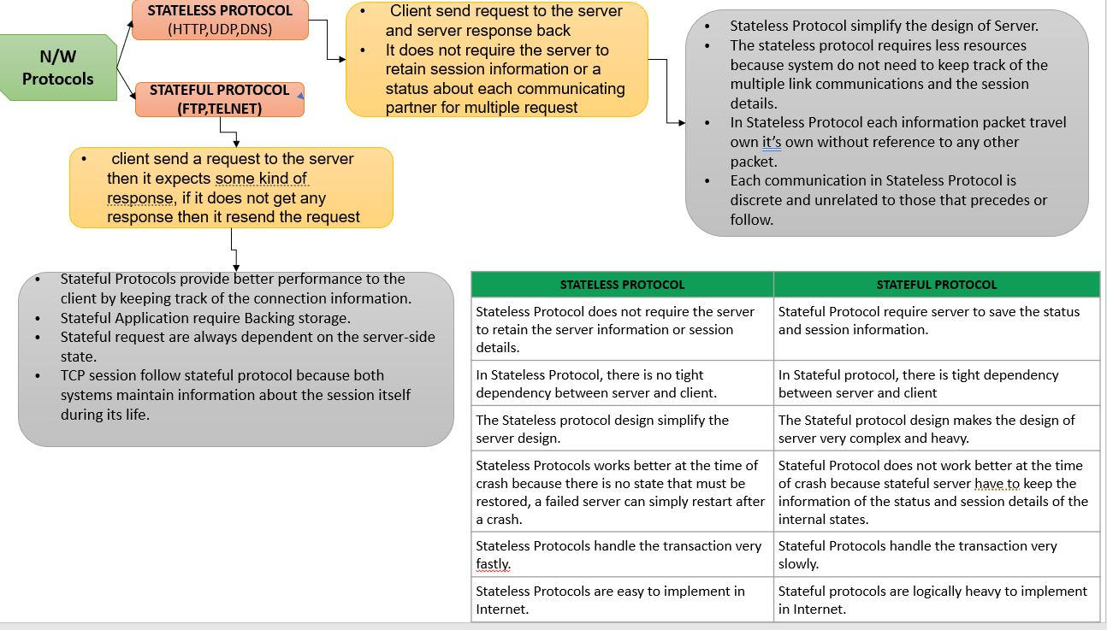

**HTTP RESPONSE/STATUS CODES:**

**HTTP status codes provides information about the outcome of the operation success, failure or updated. There are about 55 status codes divided among 5 categories**.

**1xx (Informational): Request received, server is continuing the process.**

* 100 Continue: The server received the request and in the process of giving the response.

-------------------------------------------------------------------------------------------------------

**2xx (Success): The request was successfully received, understood, accepted and serviced.**

* + - 200 OK: The request is fulfilled.
    - 201: created
    - 203:
    - 204:No content

--------------------------------------------------------------------------------------------------------

**3xxx->Redirect**

* **301 Move Permanently**: The resource requested for has been permanently moved to a new location. The URL of the new location is given in the response header
  + - called Location.The client should issue a new request to the new location.
    - Application should update all references to this new location.
* **302 Found & Redirect (or Move Temporarily):** Same as 301, but the new location is temporarily in nature. The client should issue a new request, but applications need not
  + - update the references.
  + **304-Nothing was modified by the request**

**-----------------------------------------------------------------------------------------------------------------------------------------**

**4xxx->Client side issue**

* **401-Unauthorized** (Credentials are not valid)
* **403**-Credentials are valid ,but **don't have permission to access the resource**
* **404-Resource not found (**Wrong URI)
* **405-Method Not Allowed (**A read-only resource could support only GET)
  + - * + In header's🡪Content-Type ->application/json
* **406 (Not Acceptable)**:It is when you can't send what they want
* For example, a client request for data formatted as application/xml will receive a 406 response if the API is only willing to format data as application/json
* **415 (Unsupported media type)**:When they send what you don't want
  + - * + Content-Type, Content-Encoding
* **429 Too Many Requests** - The error is used when there may be DOS attack detected or the request is rejected due to rate limiting

-----------------------------------------------------------------------------------------------------------------------------------------------------

**5xxx->Server side issue**

**500** (Internal server Error):

* The **server has encountered a situation it doesn't know how to handle**.

**503** (**Service Unavailable**):

* The server is not ready to handle the request. Common causes are a **server that is down for maintenance or that is overloaded**.

**504 (Gateway Timeout)**:

* This error response is given when the server is acting as a gateway and **cannot get a response in time**. (**Ex: Receiver system service has 5 min timeout set, if it couldn't process the request in 5 minutes ,it returns error with '504' http response code back to user.**)